

**KULLIYAH OF INFORMATION AND COMMUNICATION TECHNOLOGY**

**CSC 1100 ELEMENTS OF PROGRAMMING**

**SEMESTER 1, 2017/2018**

**SECTION 4**

**GUESSING GAME : MASTERMIND**

**GROUP NAME : IBN AL-NAFIS**

**PREPARED BY:**

|  |  |
| --- | --- |
| **NAME** | **MATRIC NO.** |
| Ahmad Zaidan bin Adnan | 1718733 |
| Muhammad Salikin bin Ismail | 1711083 |
| Mohd. Syafiq Asyraf bin Samsudin | 1715447 |
| Mohamad Zaki bin Jaafar | 1719207 |

**LECTURER**

MDM. SURIANI BINTI SULAIMAN

**DUE**

25 DECEMBER 2017

**INTRODUCTION**

The project that we had done is developing a program that brings the board game Mastermind into an interactive program on the computer. The program developed is called Guessing Game: Mastermind. The only difference between the original board game and the program is the board game requires two players who are the code maker and the code breaker while the program only requires a code breaker because the code is designed by the program itself. Basically the game gives the player ten turns to guess the four correct colours ordered by the program. Moreover, the program gives hints to the player during the game. The hints are the number of correct colours in the right position and the number of correct colours in the wrong position. In order to win the game, the player must guess the correct colours in the correct positions for ten tries or less. The score for the player is calculated referring to the number of turns used.

**FLOWCHART OF THE PROGRAM**

**main()**

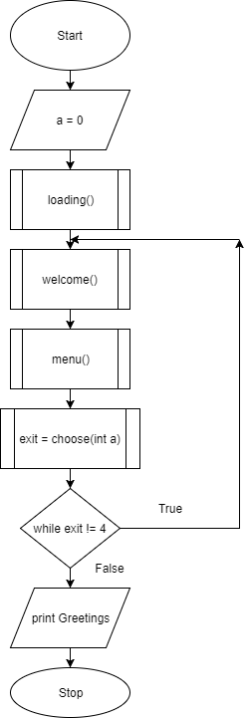

**menu()**

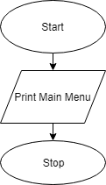

Return

**choose()**

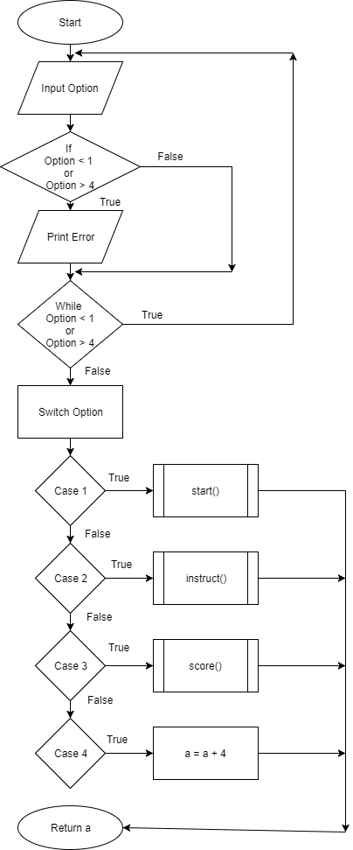

**start()**

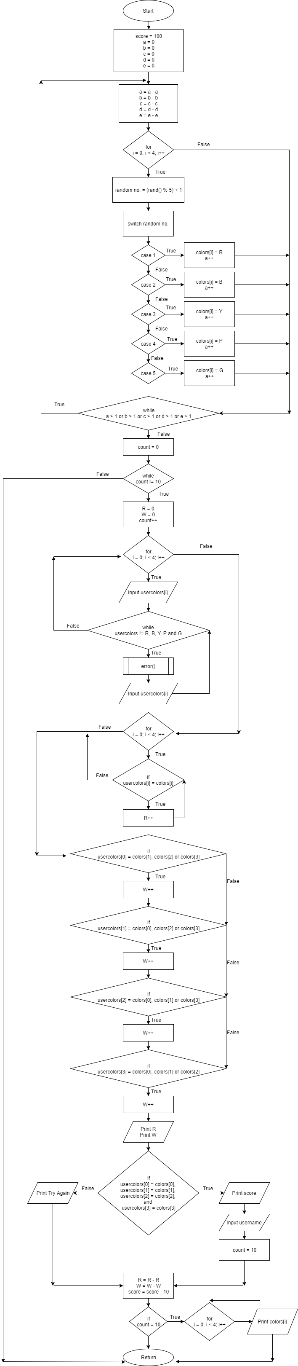

**error()**

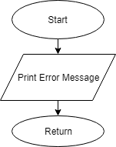

**instruct()**

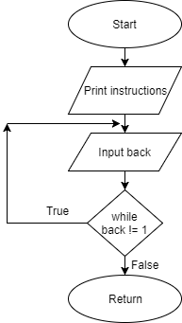

**score()**

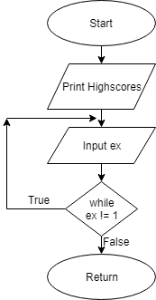

**LIST OF FUNCTIONS**

1. main()

This function calls the important functions in the program.

1. loading()

This function shows the loading bar of the program.

1. welcome()

This function shows the title of the game which is Mastermind.

1. menu()

This function shows all the options in the main menu.

1. choose()

This function lets the user choose the options in the main menu before.

1. start()

This function starts the game which is the main purpose of the program.

1. error()

This function prints the error message when the user enters the wrong inputs.

1. instruct()

This function shows the instructions of the game.

1. score()

This function shows the high scores of the players in the game.

**SCREENSHOTS OF THE PROGRAM**

1. Main Menu

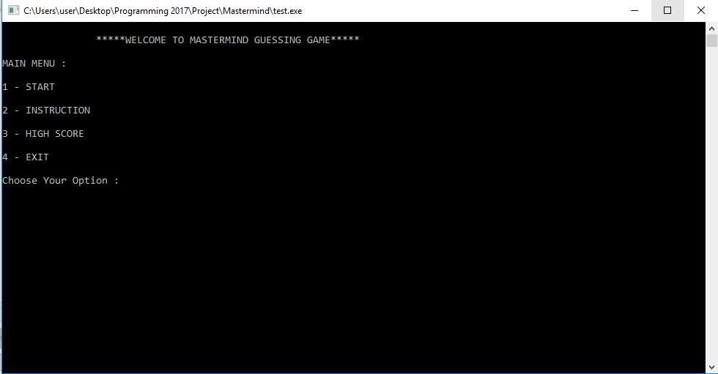

1. The game

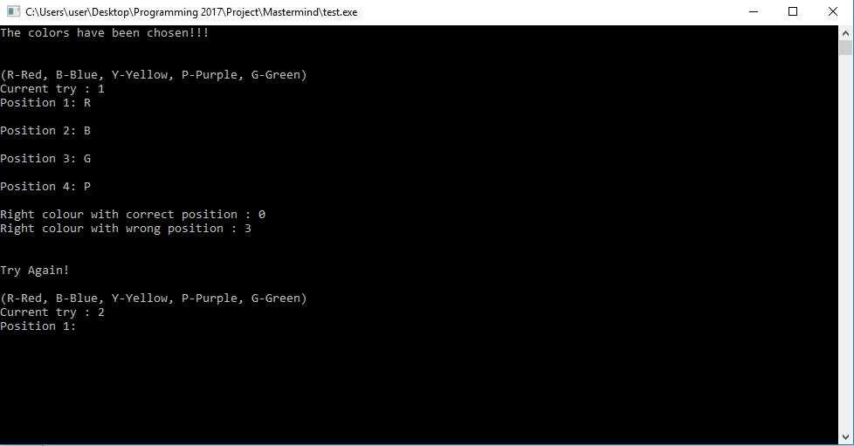

1. Instruction of the game

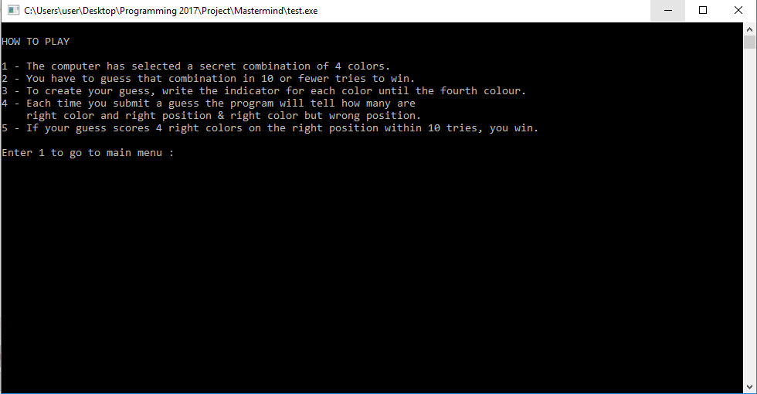

1. High scores of the game

